

Reading List

This reading list is simply a starting-point to support parents and children when selecting suitable books to read at home.
You might like to try some of these titles listed or explore different books by the same author.

We hope you will enjoy reading and talking about these books with your child.

Nursery
Where’s Spot?
Eric Hill (Puffin)

Dear Zoo
Rod Campbell (Puffin)

You Choose
Pippa Goodhart and Nick Sharratt (Random House)

We’re Going on a Bear Hunt
Michael Rosen (Walker Books)

Brown Bear, Brown Bear, What Do You See?
Bill Martin Jnr and Eric Carle (Windmill Books)

Jasper’s Beanstalk
Nick Butterworth and Mick Inkpen (Hodder)

The Very Hungry Caterpillar
Eric Carle (Puffin)

Hairy Maclary from Donaldson’s Dairy
Lynley Dodd (Puffin)
Find
Each Peach Pear Plum
Allan and Janet Ahlberg (Puffin)

Hug
Jez Alborough (Walker Books)

The Train Ride
June Crebbin (Walker Books)

Come on, Daisy!
Jane Simmons (Orchard Books)

Reception
Owl Babies
Martin Waddell (Walker Books)

The Gruffalo
Julia Donaldson (Macmillan)

Handa’s Surprise
Eileen Browne (Walker Books)

Mr Gumpy’s Outing
John Burningham (Bloomsbury)

Rosie’s Walk
Pat Hutchins (Random House)

Six Dinner Sid
Inga Moore (Hodder)

Mrs Armitage
Quentin Blake (Random House)

Whatever Next
Jill Murphy (Macmillan)

On the Way Home
Jill Murphy (Macmillan)

Farmer Duck
Martin Waddell (Walker Books)

Goodnight Moon
Margaret Wise Brown (HarperCollins)

Shhh!
Sally Grindley (Bloomsbury)

Year 1
Peace at Last
Jill Murphy (Macmillan)

Can’t You Sleep Little Bear?
Martin Waddell (Walker Books)

Where the Wild Things Are
Maurice Sendak (HarperCollins)

The Elephant and the Bad Baby
Elfrida Vipont and Raymond Briggs (Puffin)

Avocado Baby
John Burningham (Bloomsbury)

The Tiger Who Came to Tea
Judith Kerr (HarperCollins)

Lost and Found
Oliver Jeffers (HarperCollins)

Knuffle Bunny
Mo Willems (Hyperion Books)

Beegu
Alexis Deacon (Random House)

Dogger
Shirley Hughes (Random House)

Cops and Robbers
Alan and Janet Ahlberg (Puffin)

Elmer
David McKee (Andersen Press)

Year 2
Traction Man is Here
Mini Grey (Random House)

Amazing Grace
Mary Hoffman (Frances Lincoln)
Find
Pumpkin Soup
Helen Cooper (Corgi)

Who’s Afraid of the Big Bad Book?
Lauren Child (Orchard Books)

Dr Xargle’s Book of Earthlets
Tony Ross (Andersen Press)

Gorilla
Anthony Browne (Walker Books)

Emily Brown and The Thing
Cressida Cowell (Orchard Books)

The Hodgeheg
Dick King-Smith (Puffin)

Flat Stanley
Jeff Brown (HarperCollins)

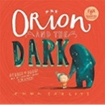 | Orion and the Dark  Emma Yarlett
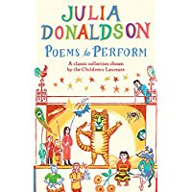 | Poems to Perform  Julia Donaldson

Year 3
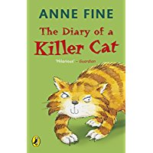 | Diary of a Killer Cat  A Fine
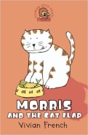 | Morris and the Catflap  V French
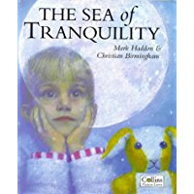 | Sea of Tranquility  M Haddon
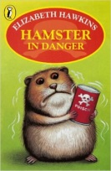 | Hamster in Danger  E Hawkins
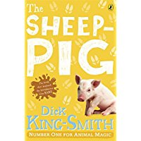 | Sheep Pig  D King-Smith
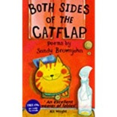 | Boths Sides of the Catflap  S Brownjohn
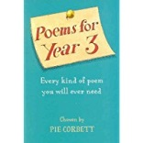 | Poems for Year 3  P Corbett
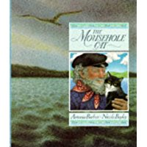 | Mousehole Cat  A Barber
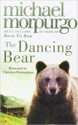 | Dancing Bear  M Morpurgo
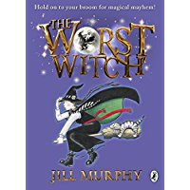 | The Worst Witch  J Murphy

Year 4
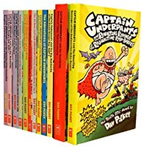 | Captain Underpants series  Dav Pilkey
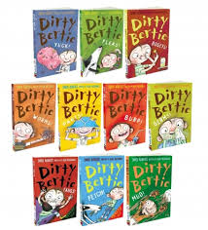 | Dirtie Bertie series  David Roberts
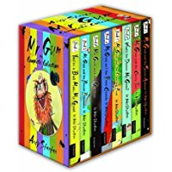 | Mr Gum series  Andy Stanton
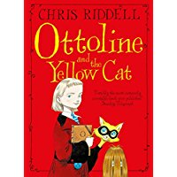 | Ottoline and the Yellow Cat  Chris Riddell
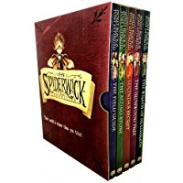 | The Spiderwick Chronicles  Tony Diterlizzi
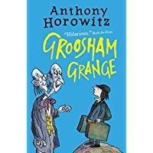 | Groosom Grange  Anthony Horowitz
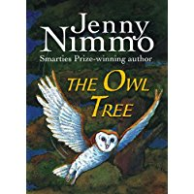 | The Owl Tree  Jenny Nimmo
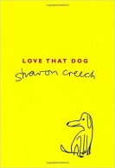 | Love that Dog  Sharon Creech
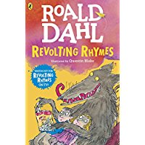 | Revolting Rhymes  Roald Dahl

Year 5
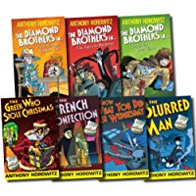 | Diamond Brothers series  Anthony Horowitz
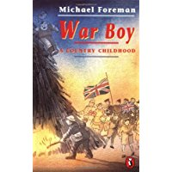 | War Boy  Michael Foreman
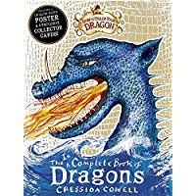 | Dragon Books  Cressida Cowell
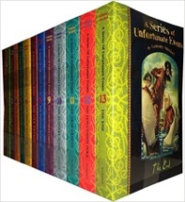 | A Series of Unfortunate events  Lemony Snickett
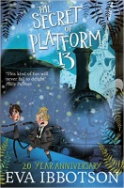 | Secret of Platform 13, Dial a Ghost  Eva Ibbotson
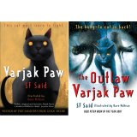 | Varjak Paw series  S F Said
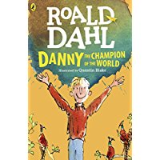 | Danny the Champion of the World  Roald Dahl
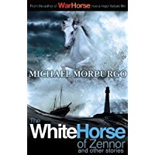 | The White Horse of Sendor  Michael Morpurgo
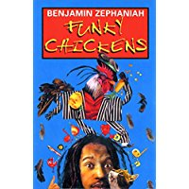 | Funky Chickens  Benjamin Zephaniah

Year 6
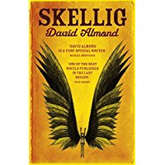 | Skellig  David Almond
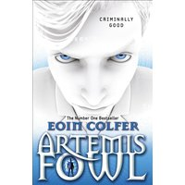 | Eion Colfer  Artemis Fowl series
 | Johnny and the Bomb  Terry Pratchet
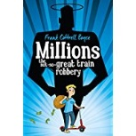 | Millions  Frank Cottrell Boyce
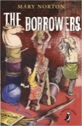 | The Borrowers  Mary Norton
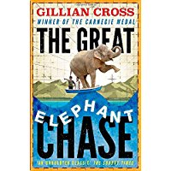 | The Great Elephant Chase  Gillian Cross
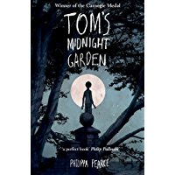 | Tom’s Midnight Garden  Phillipa Pearce
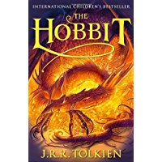 | The Hobbit  JRR Tolkein
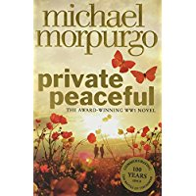 | Private Peaceful  Michael Morpurgo
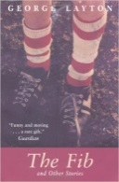 | The Fib and Other stories  George Layton

