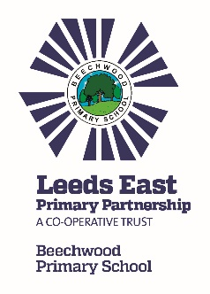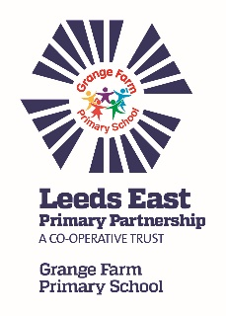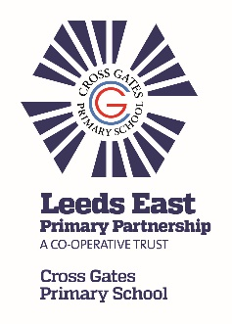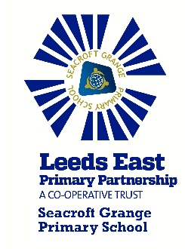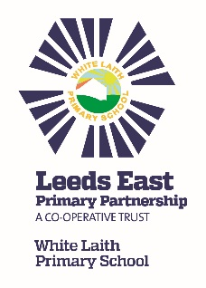

Trust News Update

Our Trust schools (Beechwood, Cross Gates, Grange Farm, Seacroft Grange & White Laith) have worked together to provide even better outcomes and opportunities for children, their families and the wider community.
What activities has the Trust been working on?
The Trust has developed a number of activities which will benefit your children, including:

- Cue cards to promote use of high quality vocabulary in Mathematics. These have been produced by the ‘Maths’ group set up by the Trust, which involves staff from all Trust schools. Cards will be launched across all year groups in September.

- Creation of a maths progression document to support teachers in all schools to embed use of the agreed vocabulary across the trust from nursery to year 6.

- Developed video exemplification materials to show age related expectations for the use of mathematical language in each year group.

- Maths leaders explored good practice and development through ‘showcase and surgery’ sessions across the Trust schools, supported by an external consultant.

- Joint training days which have enabled high quality training on retrieval and metacognition and provided an opportunity for staff across schools to meet and share ideas.

- Termly joint staff meetings to moderate writing together.

- Joint subject leaders meetings to discuss assessment in wider curriculum and share best practice.

- Sharing best practice amongst Business Managers with a focus on getting best value.

- Speech and language leaders led learning walks in each of their schools to demonstrate use of high quality key communication principles.

- Inter-school sporting competitions in various sports provided more opportunities for children to engage in physical activities and team games.

- Year 5 classes have taken part in a ‘Let’s Get Talking’ speaking and listening competition. The children demonstrated their presentation and delivery skills.

To celebrate our Trust being 10 years old we are looking to create a once in a lifetime Arts Legacy Event in partnership with Leeds Heritage Theatres, Northern Ballet and Leeds Playhouse. Our amazing children will have the opportunity to attend an exclusive performance of The Enormous Crocodile or Oliver at our partner venue in December. Further details to follow.

For further information about the Trust, please look at our website http://www.leedseastprimarypartnership.co.uk. We will continue to work on further activities to benefit your children

We wish you all a lovely summer!

