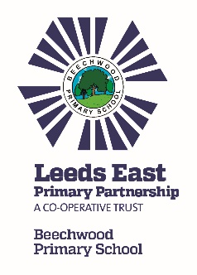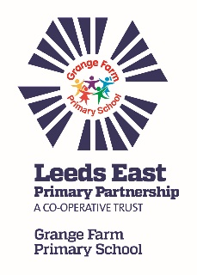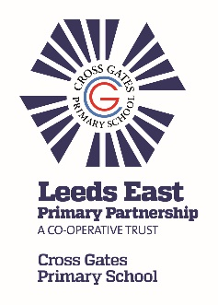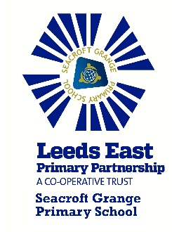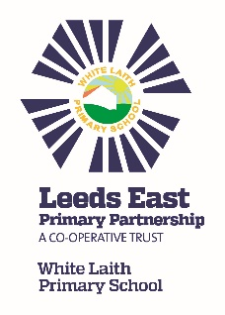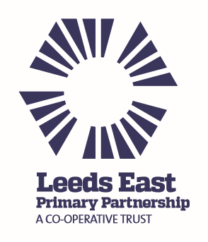

Trust News Update

Our Trust schools (Beechwood, Cross Gates, Grange Farm, Seacroft Grange & White Laith) continue to work together to provide even better outcomes and opportunities for children, their families and the wider community.

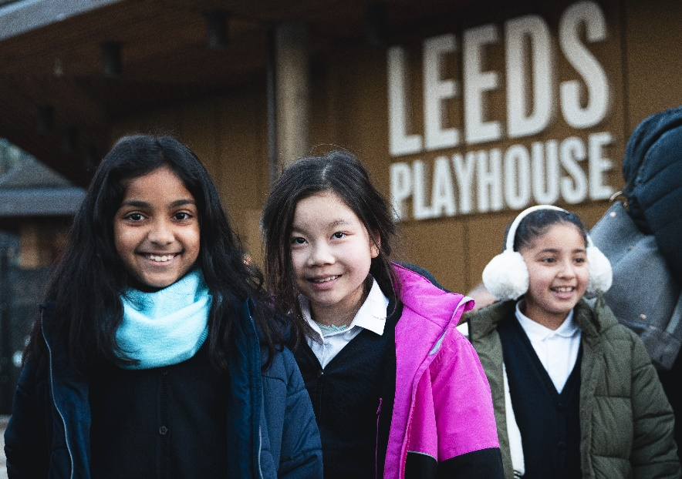

The highlight of the year had to be our visit to Leeds Playhouse to celebrate 10 years of our LEPP partnership. All children from all Trust schools attended a live theatre production of either Oliver! Or The Enormous Crocodile.
We worked with our Arts partners, Leeds Heritage Theatres, Leeds Playhouse and Northern Ballet to make the event happen and provided a Continuing Professional Development (CPD) day for teaching staff, where drama and dance practitioners shared practical exercises to embed creativity in the classroom.
Our work was recently shortlisted for the ‘Inspirational Local Partnership Award’ at the Northern Cultural Education Awards!
Since our anniversary event, further workshops and drama clubs have been delivered, and all schools will be included in Northern Ballet’s talent-spotting programme to identify potential ballet dancers of the future.
If you haven’t already seen it, please take a look at our short video https://youtu.be/g17zfaEzQ30 which evidences the broad and deep impact of the project and features some of the children in our schools.
We would love to provide our children with further opportunities to access the arts but more financial support is needed to make this happen. Can you help by donating to our fundraiser and sharing this link with your family, friends, employers and anyone else who may be able to support? https://www.crowdfunder.co.uk/p/leeds-east-primary-partnership-arts-legacy The QR code linking to the Crowdfunding website is below.

What activities has the Trust been working on?
The Trust has developed a number of activities which will benefit your children, including:

- Cue cards were produced by the Maths’ group set up by the Trust. They were launched in September to promote use of high quality vocabulary in Mathematics.

- A joint training day with our Arts Partners improved staff confidence when teaching dance and drama and we are now incorporating more dance and drama into the curriculum.

- Termly joint year group and subject leader meetings provided opportunities for staff to work together and share best practice.

- Peer to peer reviews have had a positive impact and provided potential for learning and sharing ideas.

- Learning walks have increased awareness and provided an opportunity to learn from each other.
- There are opportunities for all staff to work together depending on need.

- Business Managers continue to support each other with a focus on getting best value.

- Inter-school sporting competitions in various sports provided more opportunities for children to engage in physical activities and team games.

- SENDCOs have worked together to conduct an audit and share best practice which has led to the next Trust training day which will focus on supporting all staff to be teachers of SEND.

- A retrieval and metacognition group has developed a set of Trust principles and documentation to ensure metacognition and retrieval strategies are at the heart of teaching practices.

For further information about the Trust, please look at our website http://www.leedseastprimarypartnership.co.uk. We will continue to work on further activities to benefit your children.

We wish you all a lovely summer!



